First of all check ACP tool version, you should use version 1_8_3.

Installation:

1. 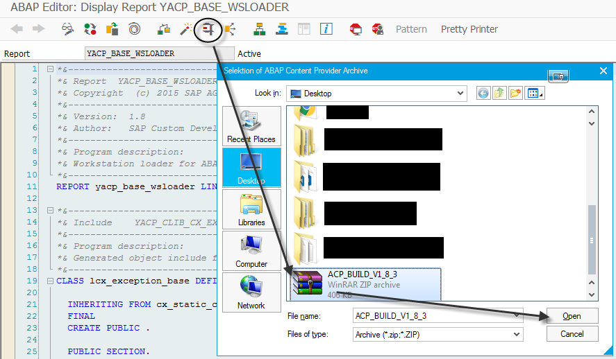Open report YACP_BASE_WSLOADER. Execute it and provide path, to your ACP archive.
2. 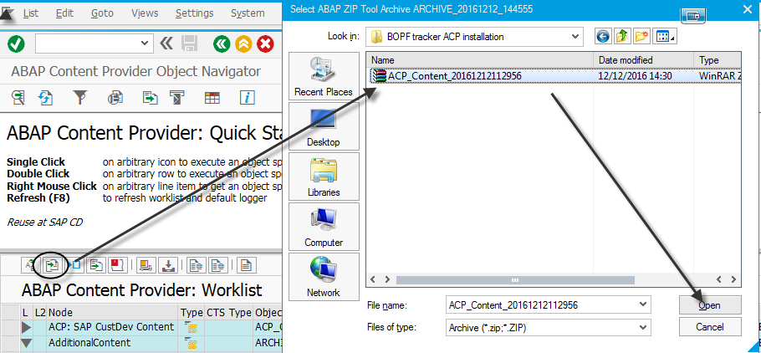Select Add object data to worklist and provide path to BOPF tracker archive.
3. Select appeared Content, press Install Selected Objects and specify new namespace if you want.

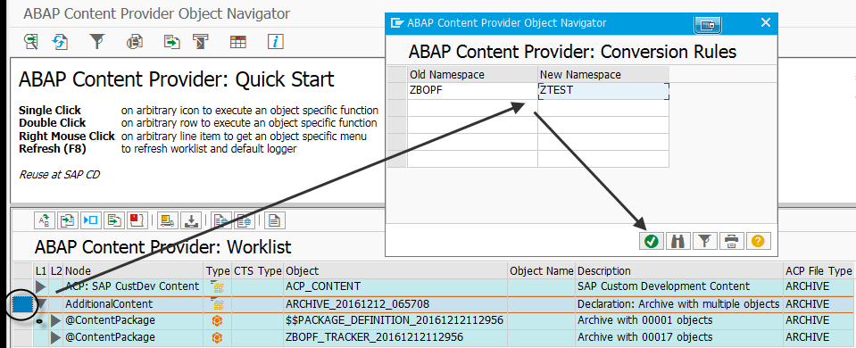

1. You should see whole list of objects, will be installed on system. Select Continue and wait for end of the installation.

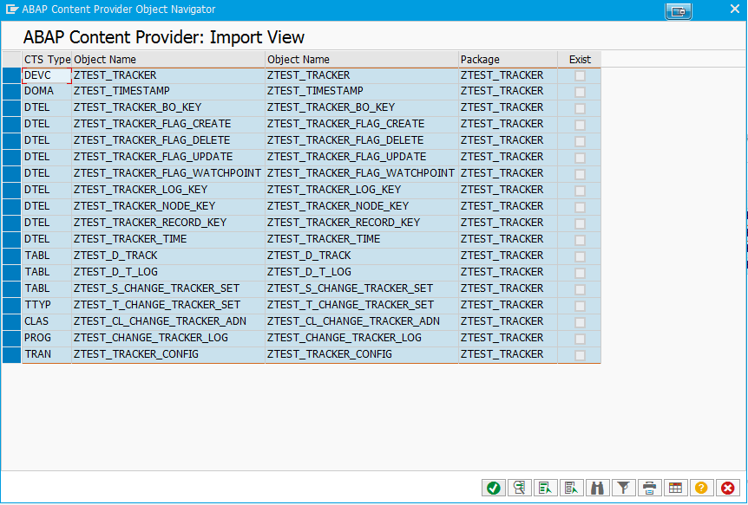

1. In case of success, you will see a similar log:

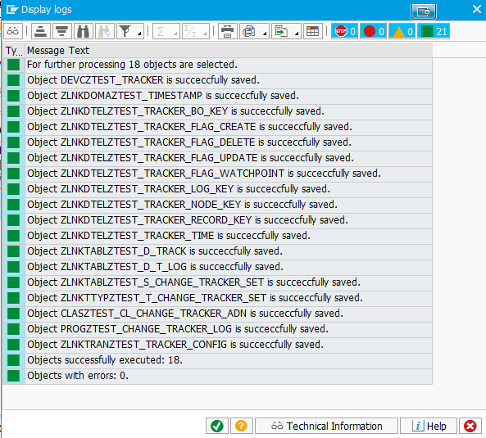

Now every object created and activated and you can use BOPF tracker.

If you have any errors, this may be due to the fact that you already have objects in system with such names. You can provide different namespace or delete existing objects, and then reinstall.